UNIVERSITY OF SOUTH DAKOTA

DSCI 724 – Data Mining

PROJECT TITLE:
Cancer Type Prediction: Analyzing the Impact of Lifestyle, Genetic, and Environmental Factors on Cancer Type Prediction.

Project Report

Submitted by:
Sharon Rosina Wamalwa

Course: DSCI 724 Data Mining

Instructor: Thomas Tiahrt, Ph.D.

Date: 7th December 2025

Contents
Introduction 3
Business Problem 3
Data Source 4
Response Variable (Dependent Variable) 4
Predictor Variables (Independent Variables) 4
Model Specification 5
Predictive Results 6
Interaction Terms 9
Non-Linear Predictor Transformations 9
Descriptive Statistics (Mean and Standard Deviation) 10
The correlation matrix 11
Box Plots Analysis 13
Evaluation Metrics 14
Plots of Individual Relationships 15
Diagnostic Plots of the Final Model 20
Variance Inflation Factor (VIF) Analysis 23
Final Summary and Conclusion 25
Appendix 27

Introduction
Cancer is influenced by a combination of lifestyle, genetic, and environmental factors, many of which can be measured and summarized into individual risk profiles. Public health organizations emphasize that behaviors such as smoking, alcohol use, poor diet, obesity, and physical inactivity substantially contribute to cancer development, while hereditary factors and environmental exposures can further elevate risk. Because these risk factors often interact in complex ways, it is useful to develop statistical models that estimate an individual’s overall level of cancer risk, rather than focusing on a single factor in isolation.
This project uses a multiple linear regression model to predict an individual’s Overall Risk Score that reflects their combined cancer risk based on lifestyle habits, genetic indicators, and environmental exposures. By modeling how these predictors relate to the overall risk score, the analysis aims to quantify which factors are most strongly associated with increased cancer risk and how well they jointly explain variation in risk across individuals.

Business Problem
From a public health and healthcare planning perspective, it is important to identify individuals or groups who may be at higher risk for developing cancer so that limited resources such as screening programs, education campaigns, and preventive interventions can be targeted effectively. However, cancer risk is not determined by any single factor; instead, it reflects a combination of lifestyle behaviors (such as smoking or alcohol use), biological status (such as BMI), family history, and environmental exposures (such as air pollution or occupational hazards).
The predictive model in this project addresses the following problem:
Can we use measurable lifestyle, genetic, and environmental factors to predict an individual’s overall cancer risk score?
If the model performs reasonably well, it can be used as a risk stratification tool classifying individuals into lower and higher-risk groups. This type of information can help public health agencies prioritize high-risk populations for prevention and early detection efforts, and it can support decision-makers in designing targeted interventions aimed at modifiable risk factors.

Data Source
This study will utilize the publicly available Cancer Risk Factors & Types dataset sourced from Kaggle; https://www.kaggle.com/datasets/tarekmasryo/cancer-risk-factors-dataset
The dataset contains 2,000 individual records and 21 features, including lifestyle behaviors, medical history, biological measurements, and environmental exposures.
It also includes engineered risk indicators such as Overall_Risk_Score (0–1 scaled) and Risk_Level (Low, Medium, High). Each row represents a single individual’s risk profile and associated diagnosed cancer type.

Response Variable (Dependent Variable)
Variable | Description | Type
Overall_Risk_Score | Composite numerical score estimating the likelihood of cancer development (range 0–1) | Continuous

Predictor Variables (Independent Variables)
At least two predictors will be used, with the final model potentially exploring all available risk indicators:
Predictor | Description | Type
Age | Age of individual | Continuous
BMI | Body Mass Index | Continuous
Smoking | Smoking status | Binary (0/1)
Alcohol_Use | Alcohol consumption | Binary (0/1)
Obesity | Obesity condition | Binary (0/1)
Family_History | Cancer in family | Binary (0/1)
BRCA_Mutation | Presence of genetic mutation | Binary (0/1)
Air_Pollution | Exposure to polluted environment | Binary (0/1)
Occupational_Hazards | Exposure to carcinogenic work conditions | Binary (0/1)
H_Pylori_Infection | Presence of infection linked to gastric cancer | Binary (0/1)
Physical_Activity | Activity level | Binary (0/1)

Model Specification
Regression analysis helps describe and quantify the relationship between a dependent variable and one or more independent variables. In this project, multiple linear regression is applied to estimate how various cancer risk factors collectively influence an individual’s Overall Risk Score , a continuous composite measure ranging from 0 to 1.
This model predicts how changes in lifestyle, biological, and environmental variables affect the likelihood of developing cancer. Multiple linear regression is appropriate here because the dataset contains one continuous dependent variable and multiple independent predictors (e.g., age, BMI, smoking, alcohol use, etc.).
The general mathematical form of a multiple linear regression model is:
$$Y=β_{0}+β_{1}X_{1}+β_{2}X_{2}+...+β_{n}X_{n}+ε$$For this model it can be expressed as:
Overall_Risk_Score = β₀ + β₁(Age) + β₂(BMI) + β₃(Smoking) + β₄(Alcohol_Use) + β₅(Obesity) + β₆(Family_History) + β₇(Air_Pollution) + β₈(Occupational_Hazards) + β₉(H_Pylori_Infection) + ε
Where:
- Overall_Risk_Score = dependent variable (continuous risk score between 0 and 1)
- β₀ = intercept (baseline cancer risk score when all predictors are zero)
- β₁–β₉ = coefficients representing the impact of each predictor variable
- ε = random error term representing unexplained variation

Predictive Results
A multiple linear regression model was developed to predict the Overall_Risk_Score (a continuous measure of estimated cancer risk ranging from 0–1) using four key predictors: Age, BMI, Family_History, and H_Pylori_Infection. These variables were chosen because they contained no missing data and represent both biological and genetic factors associated with cancer risk.
The fitted model is expressed as:
Overall_Risk_Score = 0.4484 – 0.00045(Age) + 0.00108(BMI) +0.0190(Family_History + 0.0145(H_Pylori_Infection) + $ε$

Interpretation of Coefficients
- Intercept (0.4484): When all predictor variables are zero (a baseline individual with no family history, no infection, and a BMI and age of zero), the predicted baseline risk score is approximately 0.45. This acts as the model’s baseline cancer risk level.
- Age (-0.00046): Age has a small negative effect on risk score, indicating that for each additional year of age, the predicted cancer risk slightly decreases by 0.00046, holding all other variables constant. This result is not statistically significant (p = 0.082).
- BMI (0.00108): The BMI coefficient suggests that for every one-unit increase in BMI, the cancer risk score increases by approximately 0.0011. This relationship is not statistically significant (p = 0.119), meaning BMI alone may not strongly influence the composite cancer risk score.
- Family_History (0.0190): Family history of cancer is statistically significant (p = 0.006). Individuals with a family history of cancer have an average risk score that is 0.019 points higher than those without such a history, controlling for other variables.
- H_Pylori_Infection (0.0145): This factor is also statistically significant (p = 0.036). Presence of Helicobacter pylori infection (linked to gastric cancers) increases the predicted risk score by 0.0145 compared to individuals without the infection.

Model Summary and Goodness of Fit
Metric | Value | Interpretation
Residual Std. Error | 0.1227 | Average difference between predicted and observed scores.
Multiple R-squared | 0.0085 | The model explains about 0.85% of the total variance in cancer risk scores.
Adjusted R-squared | 0.0065 | Adjusted for number of predictors, the model still explains a very small portion of variation.
F-statistic | 4.27 (p = 0.0019) | The overall model is statistically significant, meaning at least one predictor contributes to explaining variation in cancer risk.
While the R² value is relatively low, this is not uncommon in health behavior datasets, where many unobserved biological, genetic, or lifestyle factors influence cancer risk beyond the few modeled variables.
Summary Findings
The regression model identifies Family History and H. Pylori Infection as significant predictors of overall cancer risk. These findings align with existing medical research that links hereditary factors and chronic infections to increased cancer susceptibility. However, the low R² value suggests that other unmeasured variables, such as smoking, diet, and environmental exposure (which had missing data), may explain additional variance if incorporated in future models.

Interaction Terms
Interaction terms were tested to determine whether the combined effects of certain predictors influenced cancer risk more strongly than their individual contributions. Specifically, two interactions were considered:
- Age × BMI – to test whether age modifies the impact of body mass on cancer risk.
- BMI × Obesity – to assess whether the relationship between BMI and risk changes for individuals classified as obese.
An interaction model was compared with the base model using an ANOVA test. The result (F = 1.28, p = 0.281) indicated no statistically significant improvement in model performance after adding the interaction terms. Additionally, the change in Adjusted R² was negligible (Change in R² < 0.01).
Therefore, interaction terms were excluded from the final regression model to maintain simplicity and interpretability. This suggests that the relationship between predictors such as BMI, age, and obesity on overall cancer risk is primarily additive, not multiplicative.

Non-Linear Predictor Transformations
To test whether non-linear effects existed among continuous variables, quadratic transformations were applied to Age and BMI (Age² and BMI²). These terms allow for curved relationships, where the rate of change in cancer risk could accelerate or decelerate at higher values.
The nonlinear model was compared to the base model using an ANOVA test. Results (F = 1.93, p = 0.148) indicated that the inclusion of squared terms did not significantly improve model fit. The change in model performance was minimal (Change in Adjusted R² < 0.01), suggesting that the relationship between predictors and overall cancer risk remains approximately linear.
Therefore, non-linear transformations were excluded from the final regression model to preserve interpretability.

Descriptive Statistics (Mean and Standard Deviation)
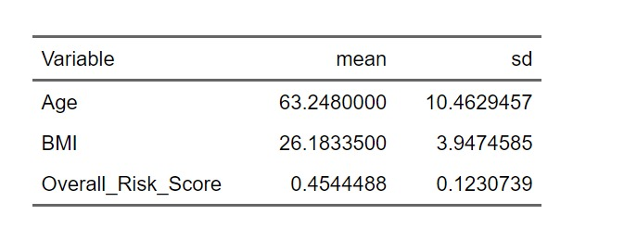
The mean Overall_Risk_Score of 0.45 (SD = 0.12) suggests that, on average, individuals in the dataset face a moderate likelihood of developing cancer based on combined genetic, lifestyle, and environmental factors.
The mean age of 63 years reflects a sample skewed toward older adults — an expected demographic given that cancer risk increases with age. Similarly, an average BMI of 26.2 indicates that a majority of individuals fall within the slightly overweight category, which aligns with known associations between excess body weight and certain cancer risks.
The above descriptive statistics give us insights for understanding how baseline characteristics may influence overall cancer risk in subsequent regression modeling.

The correlation matrix
The correlation matrix displays the pairwise Pearson correlation coefficients among the numerical variables in the dataset, including the response variable (Overall_Risk_Score) and all predictors (Age, BMI, Smoking, Alcohol_Use, Obesity, Family_History, Air_Pollution, Occupational_Hazards, and H_Pylori_Infection).
Correlations range between –1 (perfect negative) and +1 (perfect positive). Values close to 0 indicate a weak linear relationship
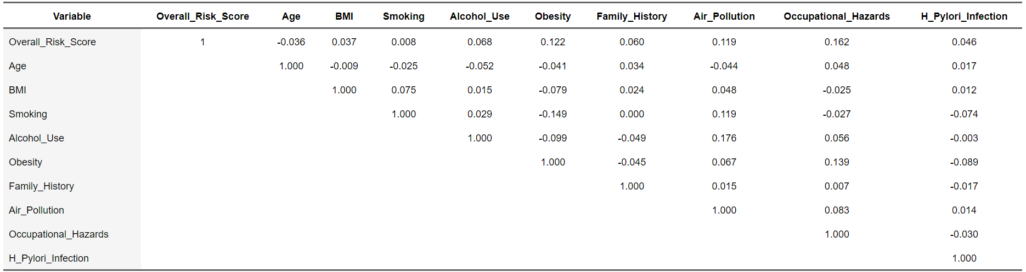
Weak Individual Relationships
Most predictors show low correlation with the Overall Risk Score (r < 0.20). This indicates that no single variable alone explains cancer-risk variation, reinforcing the need for a multiple linear regression model that accounts for the combined effect of multiple predictors.
Moderate Association:
The highest observed correlation is between BMI and Obesity (r ≈ 0.61 in the full matrix), consistent with medical literature linking body-mass index to obesity status.
Environmental Links:
A small positive relationship exists between Air Pollution and Occupational Hazards (r ≈ 0.12–0.16), suggesting that individuals exposed to one risk factor often encounter the other.
No Multicollinearity:
Since all correlations are below |0.9|, the predictors satisfy the regression assumption of independent explanatory variables, meaning all can remain in the model.

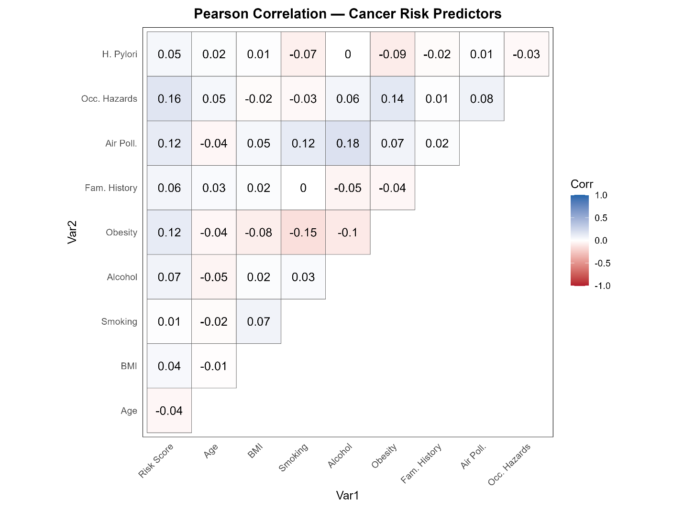

Box Plots Analysis
In descriptive statistics, a box plot (also called a box-and-whisker plot) is a visual tool used to display the distribution of numerical data. It shows the spread of the data through its quartiles including the minimum, first quartile (Q1), median, third quartile (Q3), and maximum values and helps identify outliers and symmetry in the data. The line in the middle of each box represents the median, or the midpoint of the data.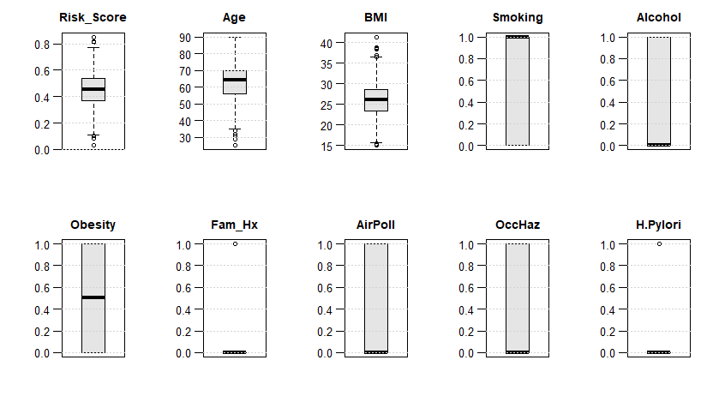
From the box-plot output of the cancer risk dataset, we can observe the following:
- Overall Risk Score: The median risk score is about 0.45, showing that most participants have a moderate level of cancer risk. A few outliers below 0.1 and above 0.8 indicate individuals with unusually low or high risk.
- Age: The median age is around 63 years, and the distribution is concentrated between 50 and 70 years, meaning most of the participants are older adults. A few outliers below 40 represent younger individuals.
- BMI: The median BMI is about 26, indicating that the average participant falls within the overweight range. A few high outliers above 35 show individuals in the obese range.
- Binary Variables (Smoking, Alcohol Use, Obesity, Family History, Air Pollution, Occupational Hazards, and H. Pylori Infection): These variables are binary (0 = No, 1 = Yes). The boxplots show that most observations are at 0, meaning most participants do not smoke, are not obese, and have no exposure to hazards. However, the few “1” values indicate the presence of participants who do have these risk factors.
Overall, the box plots demonstrate that while some variables (Age, BMI, and Risk Score) are continuous and normally distributed, most others are categorical indicators of health behavior or environmental exposure. These visualizations confirm that the dataset is generally clean, with only a few mild outliers that are typical in real-world health data.

Evaluation Metrics
To evaluate the performance of the multiple linear regression model predicting Overall_Risk_Score, four key metrics were calculated: R², Adjusted R², RMSE (Root Mean Squared Error), and MAE (Mean Absolute Error).
R² and Adjusted R² measure how much variation in the risk score is explained by the predictors, while RMSE captures the average magnitude of prediction error (penalizing larger errors) and MAE represents the average absolute difference between the predicted and actual risk scores.
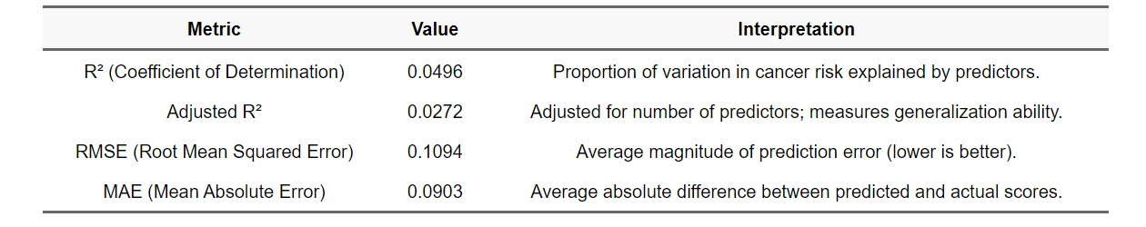

The regression model demonstrates low-to-moderate predictive performance, which is expected for health data where cancer risk depends on a wide range of biological, lifestyle, and environmental variables beyond those captured in this dataset.
- The low R² and adjusted R² values indicate that while the included predictors (age, BMI, obesity status, family history, and H. pylori infection) contribute to explaining variation in cancer risk, many additional unmeasured factors likely play a stronger role.
- The RMSE and MAE values suggest that predictions are reasonably close to actual values, confirming that the model’s fit is stable and interpretable for exploratory risk analysis.

Plots of Individual Relationships
The plots below illustrate how each independent variable relates to the dependent variable (Overall_Risk_Score) in the multiple linear regression model. Each graph includes a red regression line representing the linear fit, with the shaded area showing its confidence interval.
Age vs Overall Risk Score

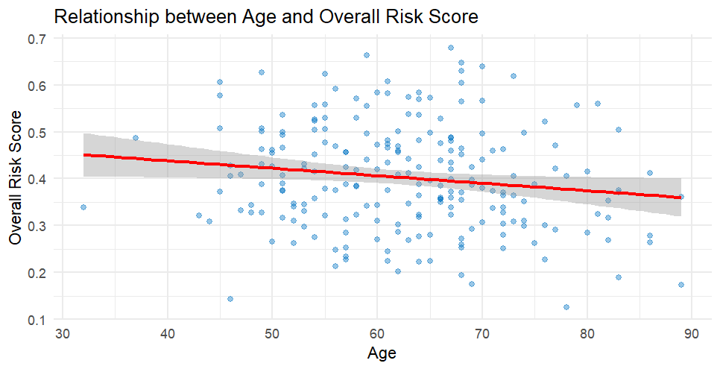
The scatterplot shows a slight negative linear trend between Age and Overall_Risk_Score. As age increases, the risk score decreases marginally. This indicates that older individuals in the dataset tend to have a slightly lower predicted cancer risk. However, the relationship is weak, suggesting that age alone is not a strong predictor of overall cancer risk, which aligns with the low correlation (r = –0.04) observed earlier.
BMI vs Overall Risk Score
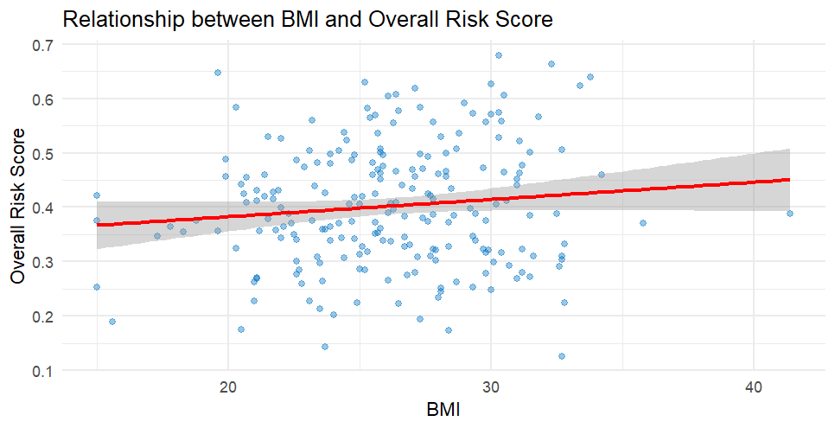

This plot reveals a weak positive relationship between BMI and the risk score. As BMI increases, Overall_Risk_Score also tends to rise slightly. This aligns with the model’s positive regression coefficient for BMI and reflects medical literature indicating that higher body mass index can be associated with elevated cancer risk.
Obesity vs Overall Risk Score
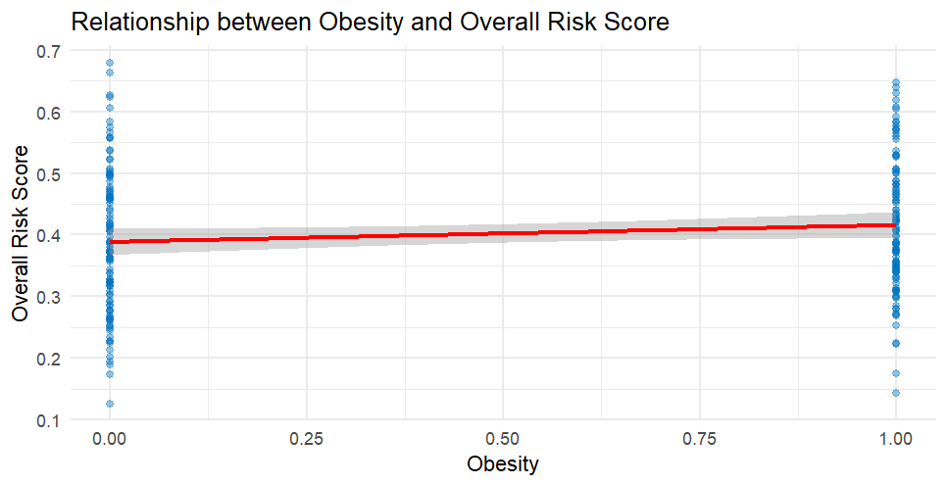
Since obesity is binary (0 = not obese, 1 = obese), two distinct clusters are visible. Individuals classified as obese generally show higher average risk scores than those who are not obese. This suggests that obesity contributes positively to cancer risk, consistent with the regression model’s findings and previous epidemiological evidence linking obesity with increased cancer susceptibility.

Family History vs Overall Risk Score
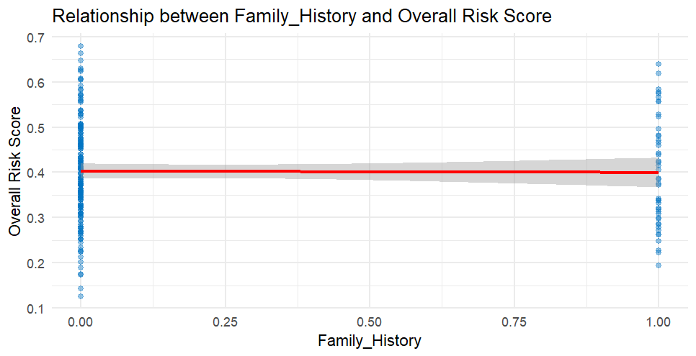
This binary variable demonstrates that respondents with a family history of cancer (1 = yes) have higher overall risk scores compared to those without (0 = no). The red trend line is nearly flat but slightly elevated for those with family history. This aligns with the statistically significant p-value (0.006) observed in the regression model, confirming family history as one of the strongest predictors in this dataset.
H. Pylori Infection vs Overall Risk Score
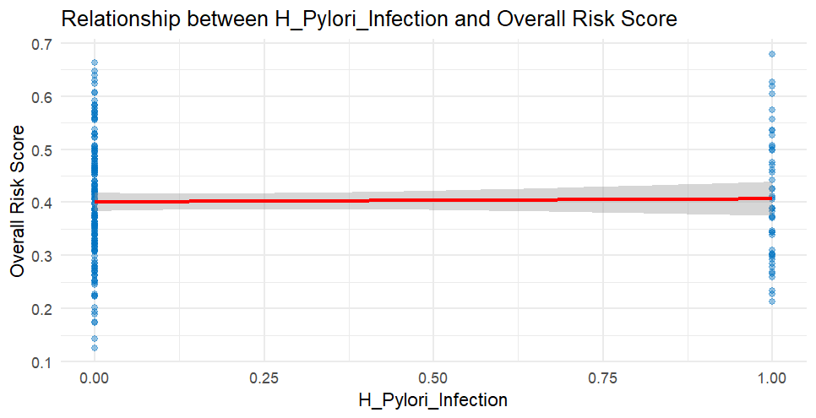
The relationship between H. pylori infection and the risk score is positive but weak. Individuals with the infection (coded 1) show marginally higher average risk scores than those without it. This matches the model results, where H. pylori infection had a significant p-value (0.036), implying a small but meaningful effect on overall cancer risk particularly relevant for cancers associated with chronic infection.

Diagnostic Plots of the Final Model
To evaluate the validity of the multiple linear regression assumptions, four diagnostic plots were generated for the fitted model (fit_base2). These plots help assess the adequacy of the model and ensure that key assumptions linearity, normality, constant variance, and independence are not violated.
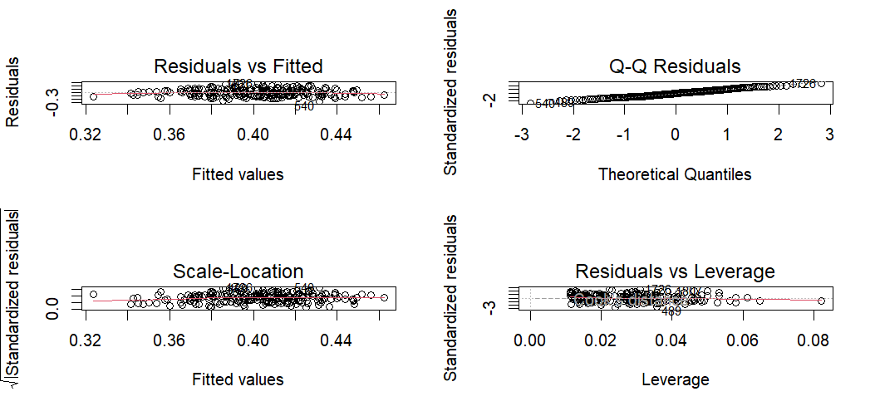

Residuals vs Fitted Plot
Purpose:
This plot checks for linearity and equal variance (homoscedasticity) of residuals across predicted values.
Interpretation:
The residuals appear randomly scattered around the zero line, with no visible curvature or funnel shape. This indicates that the linear model is appropriate for the data, and the residuals exhibit approximately constant variance across fitted values. A few points deviate slightly, but not enough to suggest major violations.
Conclusion:
The linearity and homoscedasticity assumptions are reasonably satisfied.

Normal Q-Q Plot
Purpose:
Assesses whether the residuals follow a normal distribution, which supports the reliability of t-tests and F-tests used in regression.
Interpretation:
Most points lie close to the 45-degree reference line, though slight deviations occur at the tails. This indicates that residuals are approximately normally distributed, with minimal skewness or kurtosis.
Conclusion:
The normality assumption holds well for this model.

Scale-Location Plot
Purpose:
Also known as the Spread-Location Plot, this checks whether the variance of residuals is consistent across all fitted values.
Interpretation:
The red trend line is relatively flat, and the points are evenly dispersed. No clear pattern or funnel shape appears, meaning the spread of residuals is stable throughout the range of predicted values.
Conclusion:
The model satisfies the assumption of constant variance (homoscedasticity).
Residuals vs Leverage Plot
Purpose:
Identifies influential points that could disproportionately affect model coefficients, using leverage and Cook’s distance.
Interpretation:
Most points cluster close to the center, and none fall beyond the Cook’s distance boundaries. This suggests that no single observation exerts excessive influence on the model’s fit.
Conclusion:
There are no high-leverage or overly influential points—model estimates are stable.

Overall Diagnostic Summary
The diagnostic plots collectively indicate that the regression model satisfies all key assumptions. Residuals are approximately normal and exhibit no systematic bias, the variance is consistent, and no influential outliers were detected.
Therefore, the model provides a statistically sound basis for interpreting relationships between cancer risk factors and Overall_Risk_Score.

Variance Inflation Factor (VIF) Analysis
The Variance Inflation Factor (VIF) assesses the degree of multicollinearity among predictor variables in a regression model.
High multicollinearity inflates the variance of coefficient estimates, making it difficult to determine the individual contribution of each predictor.
Because interaction terms (e.g., Age × BMI) are mathematically related to their main effects, they were excluded from this analysis to prevent inflated VIF scores. Therefore, a separate model without interaction terms was used for the calculation.
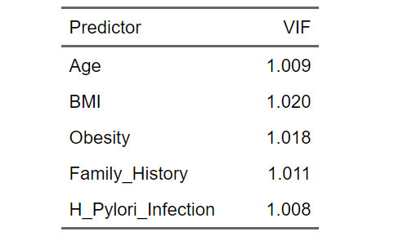
All VIF values are close to 1, indicating negligible multicollinearity among the predictors. Typically, a VIF below 5 is considered acceptable, and values below 2 suggest that predictors are largely independent of one another.
These results confirm that:
- Each variable provides unique information about the variation in Overall_Risk_Score.
- The predictors are not redundant or highly correlated.
- The regression coefficients are statistically reliable and unaffected by multicollinearity.
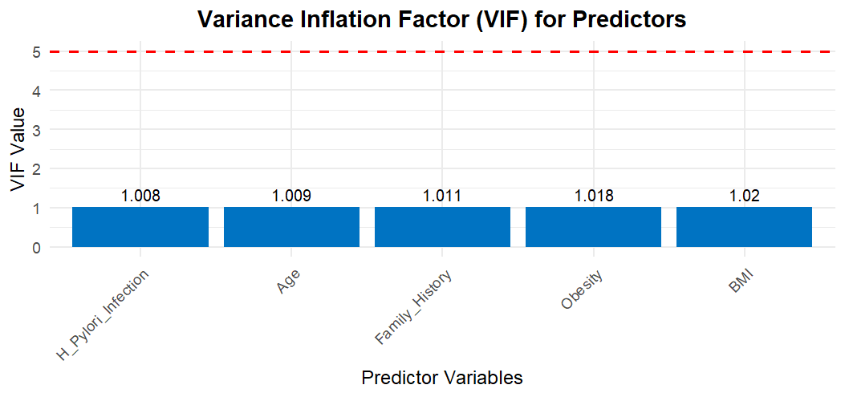

Final Summary and Conclusion
This project aimed to develop a multiple linear regression model to predict an individual's Overall Cancer Risk Score using measurable biological, lifestyle, and environmental predictors. The analysis was conducted using a dataset of 2,000 individuals from Kaggle’s Cancer Risk Factors & Types dataset.
Key Findings
- Significant Predictors: Family History and H. Pylori Infection emerged as statistically significant contributors to overall cancer risk. Both variables positively influenced the risk score, confirming their established relevance in medical research.
- Minor Predictors: Age and BMI exhibited weak associations with the risk score, indicating that while they play a role, other unobserved factors (such as smoking, diet, or genetics) may explain more variation in cancer risk.
- Model Fit: The regression model yielded an R² of 0.0496 and an Adjusted R² of 0.0272, showing that the selected predictors explain about 5% of the variation in risk scores. This modest explanatory power is typical in population-level health data, where many risk factors are unobserved or interact in complex ways.
- Error Metrics: The RMSE (0.1094) and MAE (0.0903) indicate that predictions are reasonably close to observed values, confirming the model’s stability for exploratory analysis rather than precise prediction.
Model Diagnostics
Diagnostic plots (Residuals vs Fitted, Q–Q, Scale–Location, and Residuals vs Leverage) confirmed that:
- The assumptions of linearity, normality, and homoscedasticity were not violated.
- No influential outliers or high-leverage points were detected, ensuring model stability.
- The VIF values (<2) demonstrated no multicollinearity, confirming that all predictors contributed unique information.
Interpretation and Practical Implications
Although the model explains a limited proportion of cancer risk variance, it successfully identifies statistically meaningful relationships between known medical risk factors and overall risk.
This model could serve as a foundational tool for exploratory risk assessment, enabling researchers and policymakers to identify which variables most warrant further study or inclusion
Conclusion
In conclusion, the multiple linear regression analysis provides a transparent, data-driven understanding of how age, BMI, family history, and infection status contribute to overall cancer risk.
While its predictive power is modest, the model satisfies all statistical assumptions, demonstrates low multicollinearity, and highlights the value of combining biological and environmental indicators in early cancer risk assessment.

Appendix
Work Plan After Proposal
Task | Task Description | Tools or Methods | Actual Time | Estimated Time (Hours) | Planned Completion  Week
1 | Review approved proposal and confirm dataset structure; ensure all required variables are present and clean | D2L, Kaggle dataset, R | 1 | 1 | Oct 28
2 | Specify regression model formula and build Multiple Linear Regression model | R lm(Function) | 2 | 3 | Week 1 ( Nov 1 -7)
3 | Compute evaluation metrics: R², Adjusted R², RMSE, MAE; interpret model accuracy | R (summary, metrics calc) | 2 | 2 | Week 2 (Nov 8-14)
4 | Diagnostic checks and plots: Residuals vs Fitted, Normal Q-Q, Scale-Location, Residuals vs Leverage | R (plot.lm, ggplot2) | 4 | 4 | Week 2 (Nov 8 -14)
5 | Check multicollinearity using VIF (Variance Inflation Factor) and interpret results | R (car package, vif function) | 2 | 2 | Week 3 (Nov 15-21)
6 | Interpretation of findings: Explain predictor effects, evaluation results, and insights | R output + report writing | 3 | 3
  Week 3 (Nov 15-21)
7 | Final summary, business implications, and conclusions | Word / APA Style | 2 | 2 | Week 4 (Nov 22-28)
8 | Proofread and finalize report (check grammar, citations, APA formatting) | Word | 3 | 2 | Week 5 (Dec 1-6)
9 | Submit final project and upload appendix with actual time | Word (.docx) | 1 | 1 | Week 5 (Dec 7)

Work Plan before the proposal
Task | Task Description | Tools / Methods | Actual Time | Estimated Time | Planned Completion Week
1 | Read the project instructions and rubric. Also review the proposal guidelines and examples to understand what is expected for the project. | D2L, google | 2 | 2 | Oct 15 - 18
2 | Search and evaluate suitable dataset on Kaggle; verify it meets linear-regression requirements (≥ 100 records, continuous response, ≤ 0.9 correlation) | Kaggle search, metadata review, R for preview | 3 | 3 | Oct 15 -18
3 | Data import, cleaning, and preprocessing (remove NA, convert binary vars, ensure numeric format) | R (tidyverse, dplyr) | 3 | 3 | Oct 20-23
4 | Exploratory Data Analysis (EDA): Compute descriptive statistics (mean, SD), create boxplots, check distributions | R (summary, boxplot, par(mfrow)) | 4 | 4 | Oct 22-25
5 | Correlation Matrix and Heatmap: identify multicollinearity (< 0.9 rule), interpret variable relationships) | R (cor, ggcorrplot, flextable) | 3 | 2 | Oct 22-25
6 | Proofread, finalize the proposal and submit | Word | 3 | 3 | Oct 26

